

Lab 1

CS 5-1 - BSCS – Operating System Lab

Name: Sharaiz Ahmed SAP: 57288

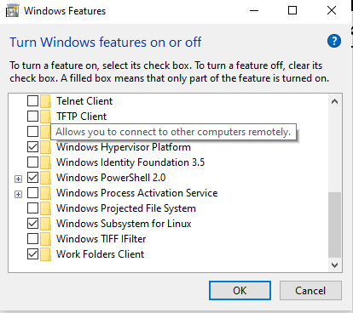
I’ve turned on subsystem for Linux on windows 10
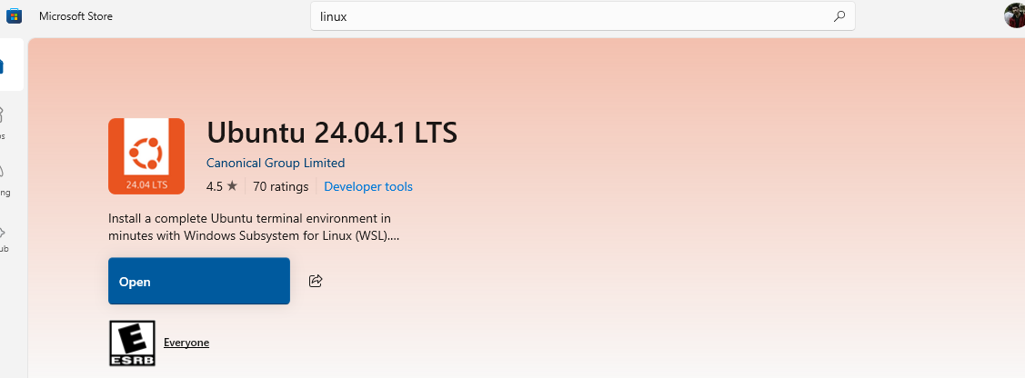
I Downloaded Ubunto from Microsoft Store

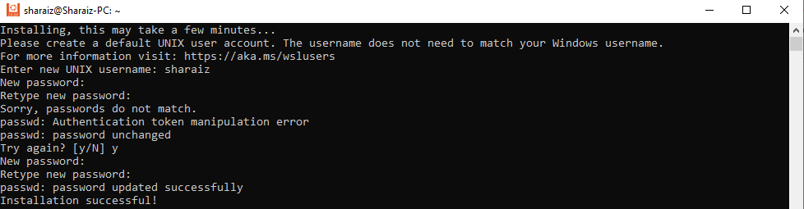
Installing Ubunto an setting up my username and password
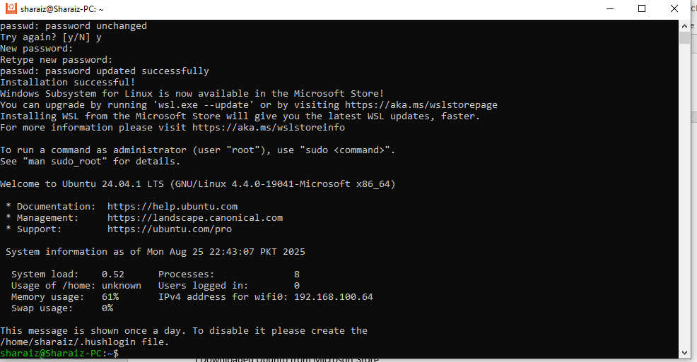
Installed Ubunto on windows 10.

